Instructions
To be completed by the applicant organisation. Please read the Applicant Guidelines carefully before filling out this form to ensure your project and organisation are eligible to apply for funding. The form must be typed and in English. All applications must be received by the Australian High Commission in Dhaka by Monday 9 August 2010. Applications can be mailed or delivered in person, and will not be accepted by e-mail. Late applications will not be accepted.
Human Rights Grants Scheme (HRGS)
Application Form (Attachment B)
April 2010
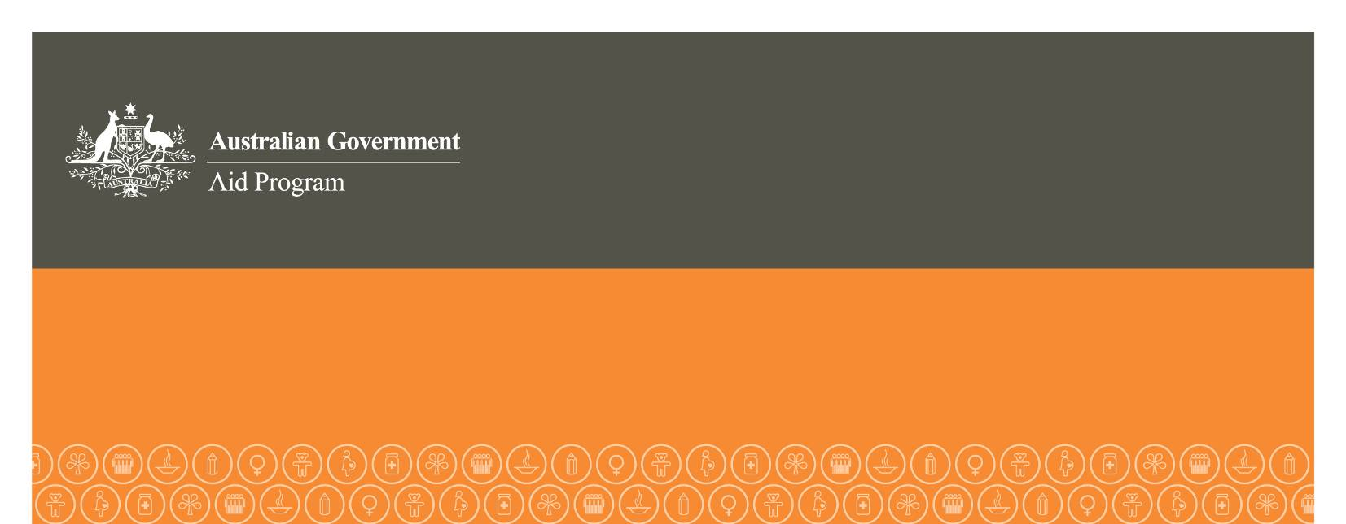

APPLICANT ORGANISATION AND CONTACT DETAILS
Name of organisation
Organisation goal or purpose
Street address
City
Country
Postcode
Name of contact person
Honorific (tick one) | Mr Ms Mrs Miss Other
Position
Contact numbers | Work Mobile  Fax
Email address

PROJECT DETAILS (maximum 8 pages)
What is the name of the project?
What amount of money is being requested (Australian dollars)?
What is the total cost of the project (Australian dollars)?
What are the project’s start and end dates?
Where will the project be undertaken?
Briefly describe the project and why it is needed.
Which of the following are objectives of this project? (Please tick one or more) | Prevent or end gross human rights violations  Promote positive change in policies or actions of government or relevant non-state actors in the area of human rights  Monitor, seek redress for and/or report on human rights violations, including supporting victims of human rights abuses  Educate and/or train human rights  victims, workers or defenders  Promote observance and  implementation of international human  rights standards  Promote and strengthen national or  regional human rights institutions or  mechanisms
Describe the main and specific objectives of this project.

How will the project’s objectives be achieved (through what activities)?
What are the project’s desired outcomes?
How will these outcomes be measured?
How will these outcomes be sustained when Australian funding ends?
What will the expected short, medium and long-term impacts of this project be?
Please complete the timeline below, setting out the project’s major activities and highlighting the month(s) in which each activity will take place
Year 1
Month: | 1 | 2 | 3 | 4 |  | 5 | 6 | 7 | 8 | 9 | 10 | 11 | 12 | Implementing body
Activity 1 (title)
Activity 2
(title)
Activity 3
(title)
Year 2 (if applicable)
Activity 1
(title)
How will you promote the project and its Australian Government funding?
What partners, if any, are involved in the project? What is their role and relationship to your organisation?
How will the project promote equality between women and men (and girls and boys)? For example by:
- increasing both women’s and men’s access to resources
- increasing women’s decision-making power
- promoting and protecting women’s, girls’, men’s and boy’s rights
- strengthening local institutional capacity to advance gender equality
- working to eliminate violence against women
Who will directly benefit from the project?
Who may indirectly benefit from this project?
Does the project involve the participation by marginalised groups? For example by:
- ensuring projects consider the needs and multiple discrimination often faced by people with disability
- partnering with or consulting disabled peoples’ organizations to ensure the needs and rights of people with disability are understood and provided for
How does the project involve local communities in developing, implementing and managing project activities?
Does the project have any other source/s of funding? If so, list each source by the name of the funding organisation and the amount of funding. |  |  |  |  | Yes No

Has the organisation previously requested Australian Government funding?  If YES, provide details on which government agency, for what project and what amount. | Yes No
Has the organisation previously received HRGS funding for this project (or any activity within this project)?  If YES, has a Project Completion Report been submitted and have the funds been acquitted?  If NO, please complete and submit all documentation listed in Section 4 of the Applicant Guidelines. | Yes No
Does the project involve working with children? | Yes No
If YES, does the organisation have a child protection policy? | Yes No  (If NO, you must commit to the development of a child protection policy as part of your project activities.)
Are there any real or potential risks associated with the project (including physical, children related, environmental, political, economic and social risks)? If YES, please outline how each risk will be mitigated.

PROJECT BUDGET (maximum 2 pages)
Expenditure (must be in Australian dollars) | HRGS funding | Implementing organisation | Other
Personnel costs
Salaries
Per diems for travel/activities
Support costs (costs directly related to the successful management of the project)
Communications
Training materials
report preparation
vehicle/transport costs
Equipment*
Freight*
Buildings*
Travel costs**
International travel
Local transportation
Audit costs***
Miscellaneous costs
TOTAL
* must not amount to more than 10% of the total project cost
** must not amount to more than 20% of the total project cost
*** the organisation must undertake an independent audit of the project and attach it to the Project Completion Report before sending the report to the Australian diplomatic post. Costs of audits must be reasonable.

